Linking to Head of Household
After an existing patient has logged onto your Website and filled out the form to request account access you will see a pop-up notice after a Websync runs showing this request. (**New Patients will not need to be linked since they do not have any information in Dentrix yet. So they will just sign in as a New Patient and fill out the New Patient form.)
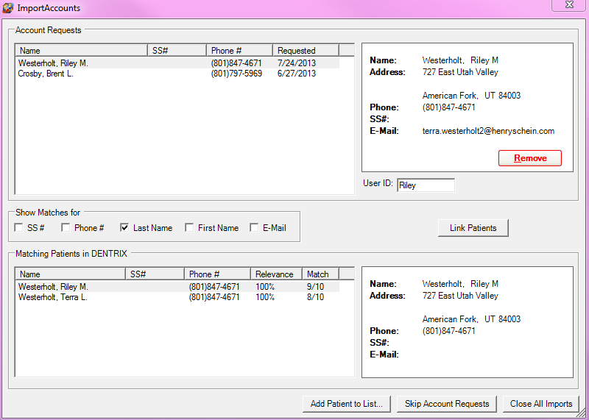
- You will see the Account Requests in the upper left hand corner of this screen. Next to it is the information they filled out on-line.
- Below this are the options you have to choose from to search for the Head of Household for this account in Dentrix.
- The lower right hand corner shows the account information in Dentrix that matched based on what was selected in the options to the request. Next to it is the information in Dentrix. **You will need to make sure to choose the Head of Household
- Once you make sure that you have the right patient selected in the “Matching Patients in Dentrix” area, you can click on the “Link Patients” button. If any of the information is different than it will let you know this and ask if you want to use the new information to update Dentrix. It’s up to you whether you want to do this now or after they have filled out the new patient forms.

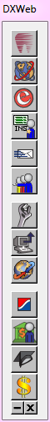
- Next, click on the DxWeb Toolbar & select “Settings” (Wrench icon)
- Select Patient Setup
- In this window you want to make sure that the checkmarks in the boxes in the lower left hand corner. If you have previously unselected Text, Email or Postcard it is OK to leave those unchecked. Everything else should be checked.

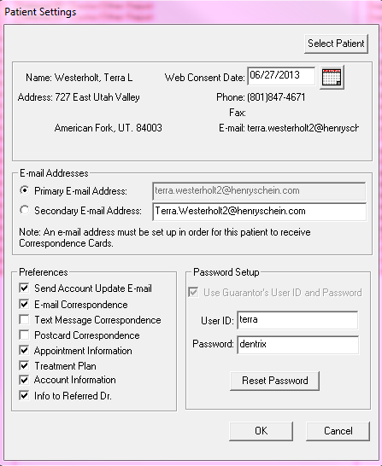

- Next click on “Upload”(computer with up arrow icon).
- Select “Patient Upload Override…” from the menu.
- Then, “OK”
- Here you can either choose the patient you want to upload or just click “Upload” to select all of them. This process takes just a few minutes, then click “OK”.

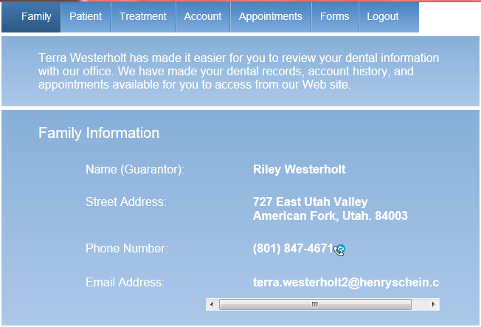
- Your patient should now be able to log onto your Website using the Username and Password they created.
- All the tabs should be available at the top whether or not you have selected to have information available for that tab.

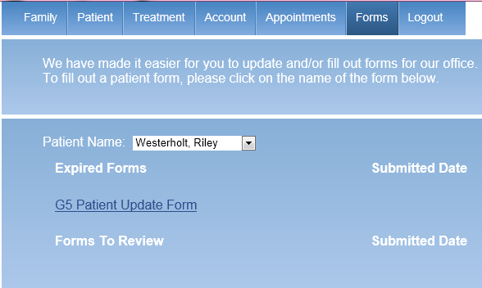
- Instruct your patients to click on the “Forms” tab to complete any New Patient or Patient Update Forms.

They do have to have an appointment within the week to have this option so that any forms are updated with recent information for their appointments.
**The patient has to be on the Appointment Book the same day for Kiosk.

