Quickbill Guide for Dentrix
Quickbill can be sent out from any computer in the office that has internet access. The setup for it is computer specific so you will need to have each computer setup if you want to send out statements electronically from those computers.
You can send out a statement individually or as a batch. To send out a batch of Statements:
Go to the Office Manager and click on Reports then Billing.

If you have already set this page up with you preferences you can just click on “OK” and your statements will be sent to the Batch Processor (Office Manager) ready to be generated.

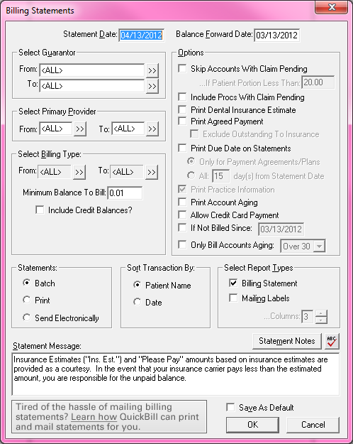

Click on the statements so they are highlighted and then click on the Electronic Billing Icon (lightning bolt over envelope).

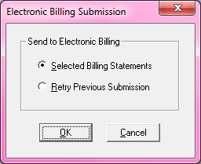

Click “OK”

You will see as your statements are being generated based on the preferences you chose in the setup screen.
When it’s done (could take several minutes depending on how large your practice is and how many accounts there are to go through).

You will see the statement information for the first statement. You can look at each Statement by clicking on the arrows at the top of the page.

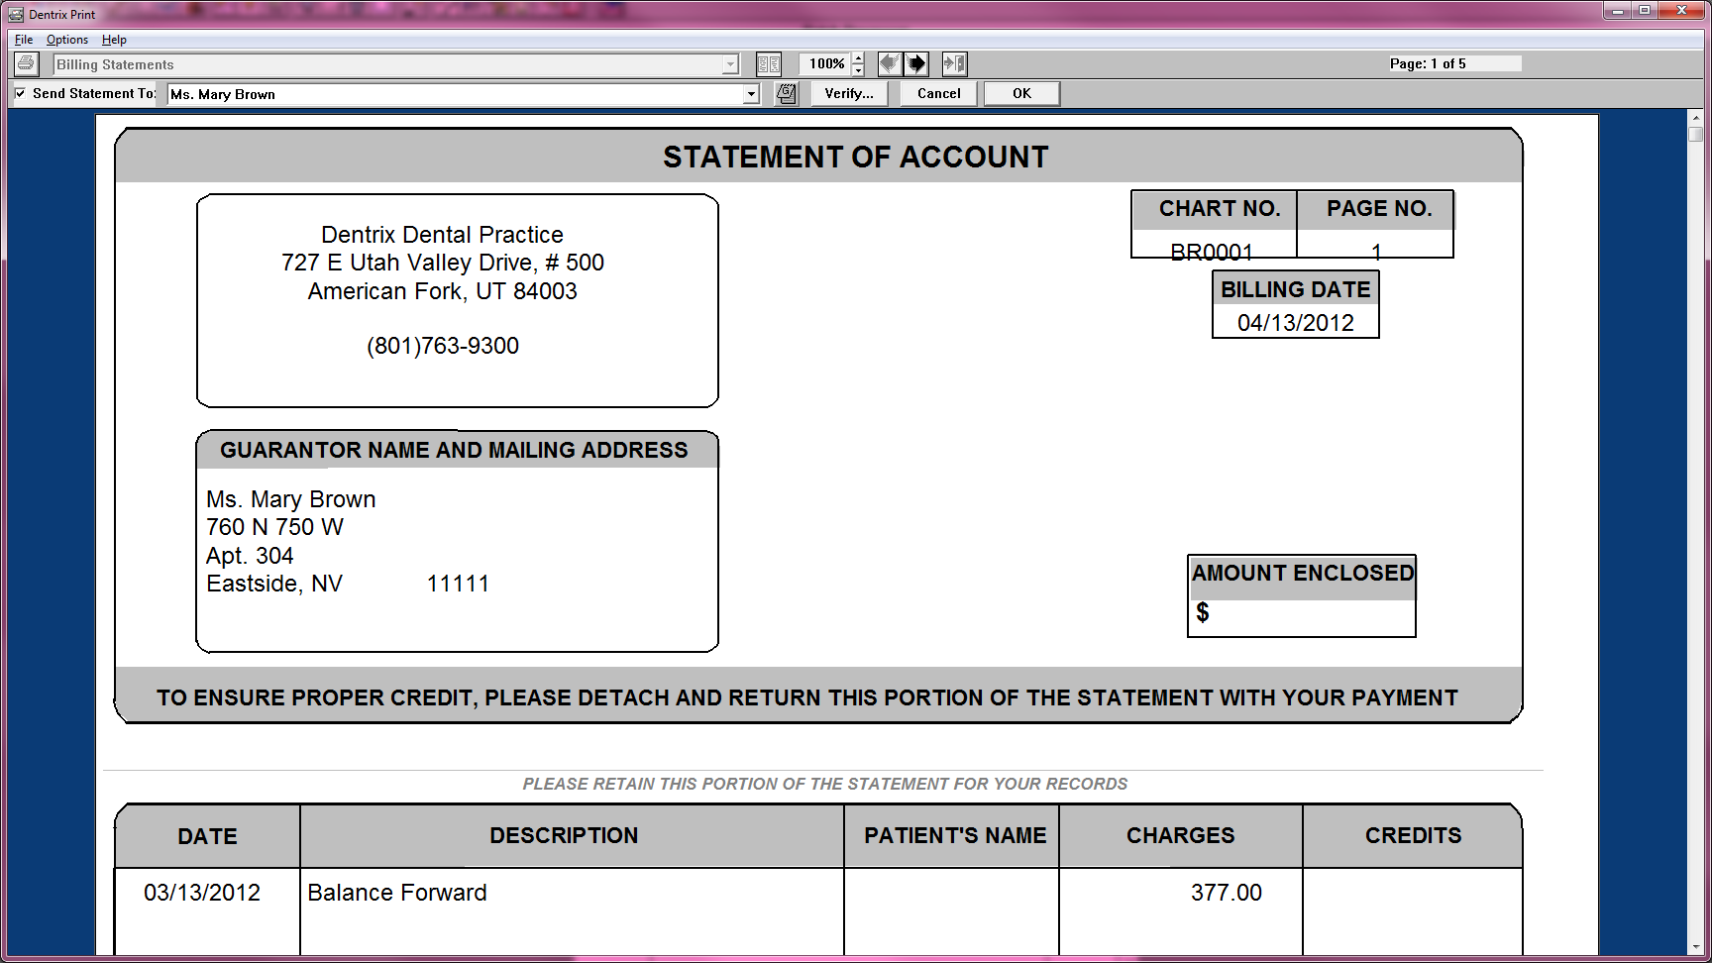

You can “take a statement out” by unchecking the “Send Statement To: box in the upper left hand corner of the Statement.

You can view the list of patients that statements were generated for by clicking on the “Verify” button. You can click on a name of a patient that you do NOT want to receive a statement to un-highlight them. This is the same thing as unchecking the box “Send Statement To:”

If you would like to add a note to the patient statement you are looking at, you can click on the Guarantor Note Icon (Upper Case “G” on a little notebook). This will allow you to add a short note to that patient about their statement. For Example: “Mary, your insurance has paid in full. The amount you see due is your balance.”

When you have finished going through all your statements and adding notes to those that needed them, you can click the “OK” button.

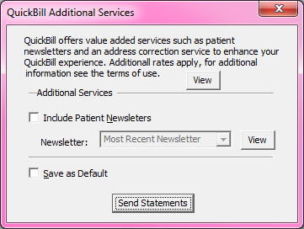
You may see this window open. It is letting you know that you can send out newsletters through your Quickbill service as well as receive address correction services. You can click the “view” button to see more information about these services. If you click on the “Save as Default” then “Send Statements” you won’t see this window again.

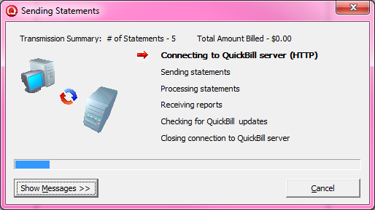
You will see the process of your Statements being sent:

Once done, you will click “OK” then “Finish”.

You should now see two reports in your Batch Processor: This is how you know your Statements went through OK.

Quickbill Report #1 is your billing statement. It shows you what you are being charged for regarding Quickbill. It will also show you any address corrections that showed up on the United States Post Office Website.

Quickbill Report #2 is an itemized list of the Statements that you sent out.

I like to “print” my reports to the Doc Center. Click on the report you want to print so that it’s highlighted and then click on the “print preview” button next to the printer icon. Once the report is showing you can click on the word “File” then “Print”. Instead of choosing your printer, change this option to “Print to Doc Center”.

Next, click on the Doc Center icon from the Office Manager. Choose the person or Practice Name you want to save this document under. When that Doc Center opens, Click on “Acquire” and then “Unfiled Documents”. When the new window opens scroll till you see todays date click on it to highlight it and then click on it and drag it over to the Doc Center you opened and let go. You have now saved it after you choose the file to save it to and name it (Ex. “Quickbill Report #2).

**If you want to send out a statement individually, you would go to that patients ledger and click on Print at the top of the page then choose “Statement”.

If you are going to be sending a few that day, you click on “Batch” to send it to the Batch Processor and send them all together by going to the Batch Processor and selecting them all by highlighting them and clicking on the Quickbill Icon and following the steps above.

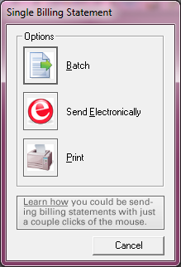
To send just one, you can click on “Send Electronically” and it will be sent right away. Just make sure you look at your Reports to see that everything went through ok.

