Quickbill Statement Options
You edit your statement options by going first to the Office Manager. Click on “Reports” then “Billing”.
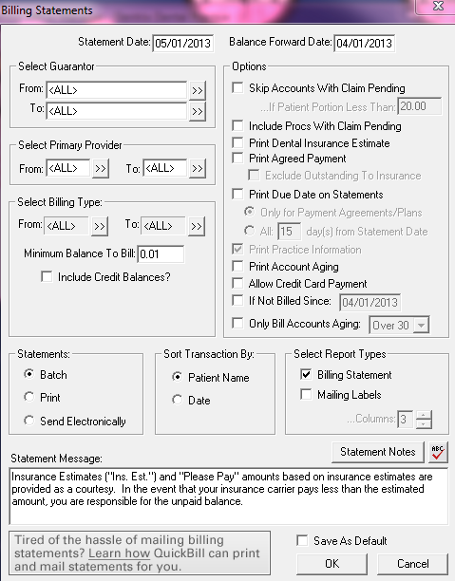

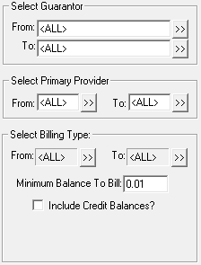
You can keep the Guarantor selection to “All” or choose patient to send statements to.
You can keep Primary Provider to “All” or select to send out statements to patients of certain providers.
You can keep Billing Type to “All” or select certain billing types to send your statements out to.
You can set the Minimum Balance to Bill to make it worth sending the statement (Ex $5.00)

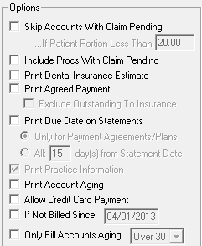
You can skip accounts with a claim pending and then set the Patient Portion to whatever amount you want.
This means if a patient was in for a cleaning and their patient portion was $8.00 then this patient would not have a statement generated. If they were also in for restorative work and their patient portion was $15.00, they would get a statement. Even though it was under $20.00, it looks at the Total Patient Portion. So it looks at the $8 + $15 which is over the $20.

“Include Procs With Claim Pending” is actually looking at any procedures that are attached to a claim that have not been closed and the Balance Forward Date. The procedures that are itemized are done to the balance forward date (usually last 30 days). Anything prior to the balance forward is included in the balance forward amount and just says “Balance Forward”. If you have this option checked, it continues to itemize procedures prior to the balance forward date if the claim has not been closed out so the patient can see Insurance is still pending.

“Print Dental Insurance Estimate” is looking at what you have entered in the Coverage Table and Payment Table area of the Insurance in the Family File.
“Print Agreed Payment” is the “Please Pay” box you can have show on the statement. This amount also looks at what you have entered in the Insurance part of the Family File.
“Print Due Date on Statements” allows you to have a date the statement is due by printed on the statement.
“Print Account Aging” itemizes your procedures to the balance forward date.
“Allow Credit Card Payment” allows the patient to enter credit card information.
“If Not Billed Since” allows you to run only statements that haven’t been billed since the date entered. *This is good for offices that send out statement after insurance pays. When you run your monthly statements and have this selected it won’t pull a statement for someone that you just billed.
“Only Bill Accounts Aging” allows you to send out statements for accounts over 30, 60 or 90 days, depending on what you selected.

**You can click the option to “Save As Default” to save these settings so that you don’t have to select them everytime you run statements.

